Huawei Website
https://e.huawei.com/en/talent/portal/#/
create a new account or use your log in information if you already have an account.
The class is under “NTI_SmartVillage” academy.

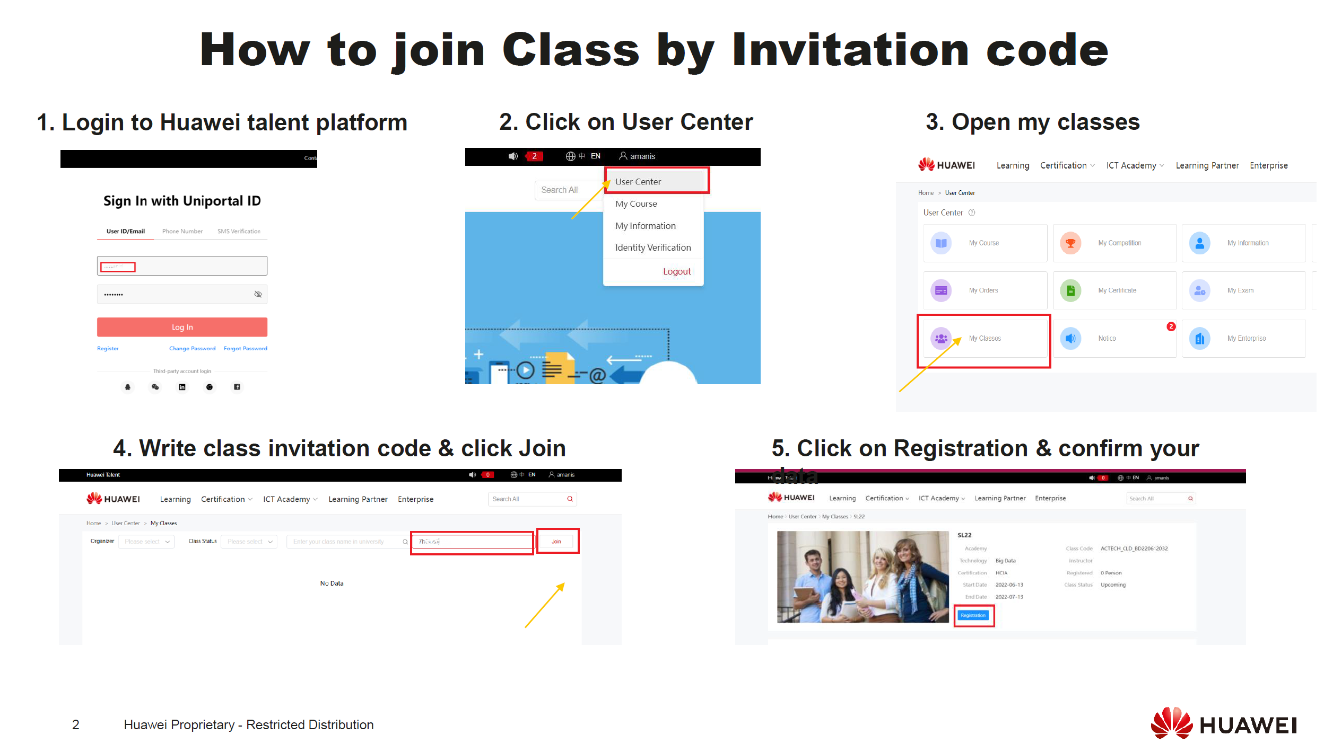

The class invitation code has been generated:
Class AI DS G5 >>>> code: BOXSZ8
Class AI DS G6>>>code: 6RtWcz
